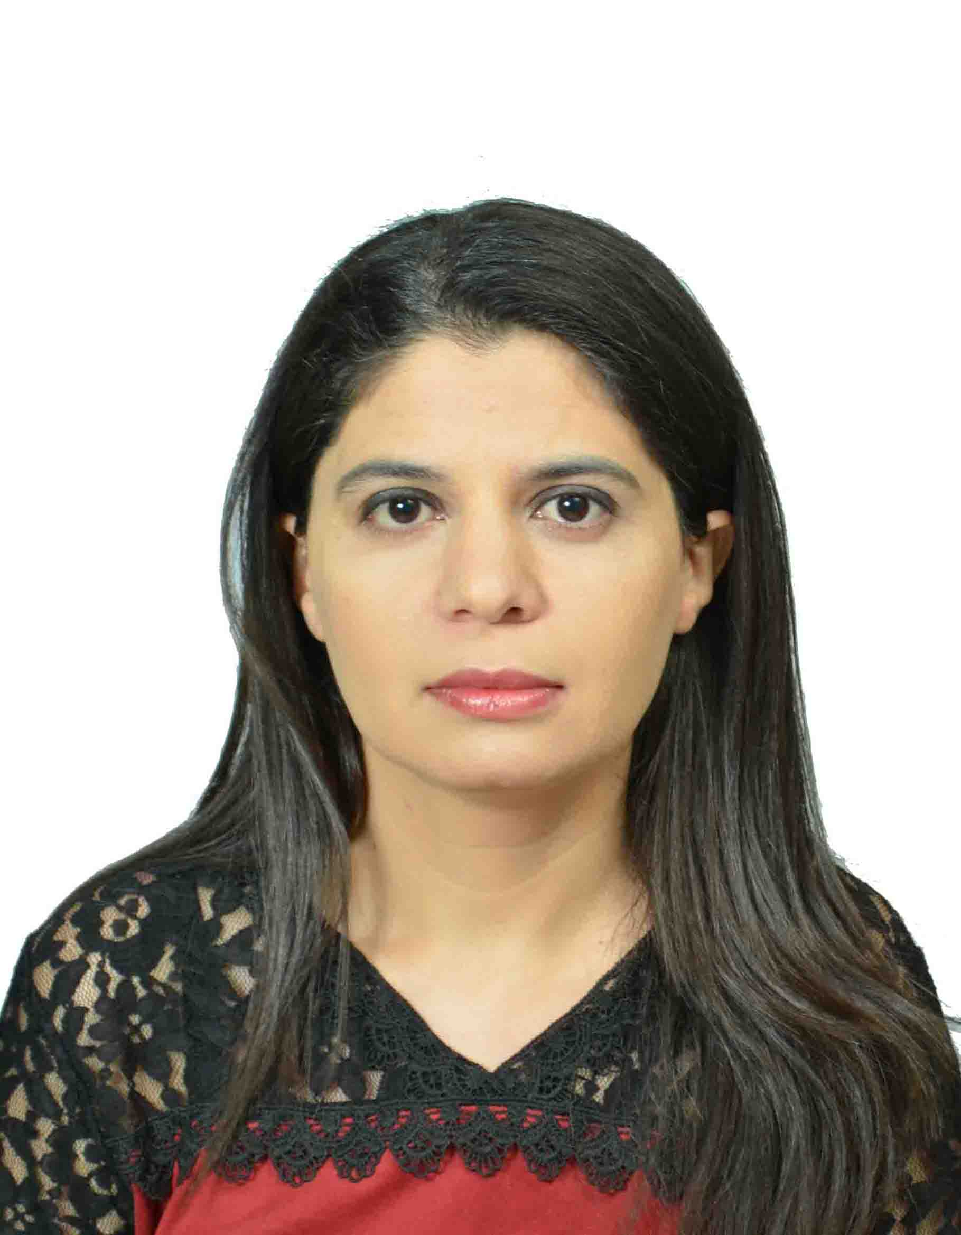
Sabiha Zehraoui
Date of Birth: 24/02/1981
Place of Birth: Koléa-Tipaza-Algeria
Marital Status : Single
Adress 1 : Bistari Condominium
Jalan 1/64d, Chow Kit, 50350 Kuala Lumpur, Malaysia
Adress 2 : 43, rue des écoles
Fouka Ville-Tipaza-Algeria
Tel : (+213)667212127
E-mail : sb.zehraoui@gmail.com

I am capable of providing consistently high standards of work and working effectively in high or low-pressure situations, able to priorities work to meet targets and deadlines.
I am a highly self-motivated, conscientious person. I work extremely well as part of a team, or individually.

I am professional and dedicated individual with a good technical knowledge and the ability to seek solutions to everyday challenges. Keen to develop new and existing skills.

Work Experience
2017 till now INTERNATIONAL ORGANIZATION FOR MIGRATION (IOM),
Algiers, Algeria Position: Senior Project Associate

Missions and tasks:
- Manage, implement and monitor the project activities in accordance with schedule. work plan and the project document.
- Act as the focal point for communication and public information activities.
- Prepare the communication tools as well as production of visibility equipment.
- Develop narrative reports, minutes of working meetings and other documents
required on all project activities in 3 languages: Arabic, French and English.
- Act as focal point on migration and health activities.
- Management of administrative and technical aspects of the project with local authorities and partners;
- Identify risks and constraints in the implementation of the project and propose solutions to overcome the issue.
- Control expenses and prepare financial reports for donors.
- Coordinate logistics and preparations needed for all the events planned in the
project framework; and facilitate field visits according to the needs of the project;
- Participate in the draft of action plans, budgets and project proposals.
- Support the Assistance to Voluntary Return and Reintegration (AVRR) program

2016 UNITED NATIONS POPULATION FUND (UNFPA),
Algiers, Algeria Position: Program Assistant

Missions and tasks:
- Participate in the draft of action plans and budgets, project documents.
- Coordinate with partners and office staff, project execution, by monitoring work plans according to expected results.
- Ensure implementation and monitoring of purchases; consider applications and initiate the procurement process for equipment, goods and services office based on transparency of projects with quality /cost ratio.
- Participate in meetings, assessment missions, field visits and prepare regular reports on the progress of activities.
- Analyze factors that affect the achievement of results, propose actions readjustment and monitoring recommendations.
- Prepare documents required for payments and initiate operations in ATLAS (requisitions ...) checking the compliance of payment requests with the procedures and the availability of resources for expenditure.
- Prepare office staff missions, consultants and partners closely with the program, administrative and financial.
- Ensure office equipment management compliance with procedures in inventory, operating and disposal.
- Collect, maintain and share data and information necessary for the drafting reports, identify and records documents of good practices and share them with partners.

2011 - 2015 United Nations High Commissioner for Refugees (UNHCR),
Tindouf, Algeria Position: Field Associate:

Missions and tasks:
- Identify and assess general and specific needs of refugees.
- Planning, monitoring and evaluation of UNHCR/ Projects and programs.
- Follow-up the Food Programs namely: nutritional program, food program at school level (School Feeding Program) and program of the fresh food.
- Contribute to the various missions of UNHCR/evaluations at the refugee’s camps level such as: Nutrition Survey, AGDM (Age, gender-based diversity mainstreaming), JAM (Joint Assessment Mission) …etc.
- Supervision and support of community outreach workers
- Contribute in the periodic and statistical reports.
- Data collection, data entry and data analyses of Home Visits program
- Ensure regular and monthly coordination with the Implementing Partners.
- Write and submit the reports, notes of the meetings, notes on regular visits in the field and other missions, in English, French and Arabic.
- Translate in three language English, French and Arabic.
- Contribute in the different events and awareness sessions such as: World Refugee Day, International Woman Day, Fight against HIV/AIDS and the Universal declaration of the Human Rights…etc.)

2009 – 2010 Carrefour Electronique,
Algiers, Algérie Position : Technical-commercial

Missions and tasks :
- Reception and orientation of customers.
- Preparation of bills and invoices via the software (Sage).
- Follow-up the stock asset /evaluations/inventory.
- Follow-up sale & installation services.
- Coordinate with suppliers concerning procurment and transportation of products

2007 – 2009 URB-ARCH,
Algiers, Algeria Position : Management Assistant

Missions and tasks:
- Reception and orientation of customers.
- Prepare a diary of the appointments and visits.
- Field visits on sites that would be sold and/or rent in order to have a clear idea about the place. Then, coordinate with owners and clients.
- Make the payment of the employees.
- Coordinate with all employees to ensure work development.

Education Background
2014-2015 Master degree in International Cooperation and Humanitarian Aid
Almeria- Spain Humanitarian Aid Studies Center: Proyecto Kalu
2000-2004 Bachelor degree in Library Science
Algiers - Algeria Faculty of Human & Social Science

Professional Trainings
2016- E-learning Certificate in Procurement
Global learning centre (UNFPA)
2015- Arusha- Tanzania Certificate in Permaculture Design Course
Food Water Shelter inc and Permaculture Research Institute
2014- Istanbul- Turkey Certificate in PLP (Protection Learning Program)
Global Learning Centre Protection/UNHCR
2014- E-learning Certificate in Basics in interviewing
Global Learning Centre/UNHCR
2013- Tunis- Tunisia Certificate in SGBV (Sex Gender Based Violence /Updated strategy)
UNHCR /Tunis
2013- Nairobi- Kenya Certificate in Processing and Analysis of Data for Surveys and Assessments
Indepth Research Services
2013- E-learning Certificate in Results Based Management
Global Learning Centre/UNHCR
2013- Tindouf-Algeria Certificat in Administration and management of warehouses
World Food Program (WFP)
2012- E-learning Certificate in International Public-Sector Accounting Standards (IPSAS)
Global Learning Centre/UNHCR

Languages
Arabic: reading, writing, and speaking (fluent/Mother tongue)
English: reading, writing, and speaking (fluent/I have passed TOEIC)
French: reading, writing, and speaking (fluent/I have passed UNLPE)

Additional Information
Computer Skills: MS Office package: Word, Excel, Power Point, Outlook, Internet, Intranet… etc.
Software: Sage (commercial management)/Quantum GIS/SPSS/CSPRO
Driving license category (B)
Interests: reading books/novels, walking and travelling.

