RESUME

RAKOTONOMENJANAHARY LOUIS JAONARY  Address : Ampahidrano villa Soafihary  FIANARANTSOA 301 MADAGASCAR  Maried Two Daughters  Date of birth : 27 Januaryr 1966 Fianarantsoa Madagascar  Mobile : +261344423010/+261331100024  Email : jao.rakotonomenjanahary@gmail.com  Skype : jaorakoto | 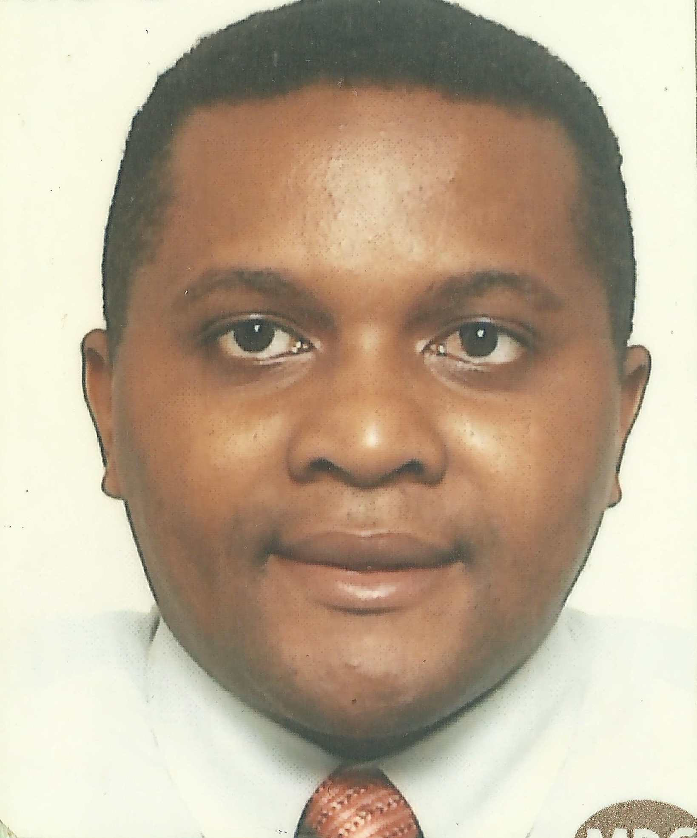

Professional Experience

December 2017- March 2019 Regional Director of Technical Education and Professional Training Haute Matsiatra Madagascar

Representative Ministry of Technical Education and Professional Training in Region Haute Matsiatra
Manage all the Technical school in the Region
Ensure the admistration and financial Management

October 2011-July 2017 Team Leader Core Network NOKIA Madagascar

Operation and Maintenance Circuits switch and Packet Switch
Daily Health check, Organization Trouble shooting, Fault Management, Change Management
Documentation Network Diagram,Update Documentation configuration Circuits Switch
Coordination with supplier in case of problem, Interface upgrade Software, Observation and Analyze KPI,Runnng HLR after Relocation, Relocation HLR APZ 21240,Monitoring status and utilization Trunk, Follow up Implementation and integration SIP Core Network
Follow up Implementation and integration AoIP, Relocation switch Ericsson APZ 21260
Migration Traffic Switch Ericsson APZ 21240,Test fonctionality Switch Ericsson APZ 21240
Acceptance test new installation Switch Ericsson APZ 21240
Assistant implementation, installation Switch Ericsson APZ 21240 for Migration

November 2009-September 2011 : 2nd Line Support Manager AIRTEL Madagascar

Operation and Maintenance 2nd Line Support, MSS, MGW Switch ERICSSON, BSS ERICSSON, TRASMISSION NEC,SRAL,SAF. Documentation system Transmission Airtel Madagascar. Test and verification Transmission equipment suspected faulty in Store
Operation, alignement, installation Equipement Transmission SAF, SRAL XD. Conception Document Network Operation Procédure Manuel. Intégration 3G Airtel Network

August 2008-October 2009 Team Leader 2nd Line Support Circuit Switch Core ZAIN Madagascar

Responsable Client Entreprise GALANA, société Pêcherie as Techical support .Integration site new switch Ericsson APZ 21260, Acceptance new switch Ericsson APZ 21260, Installation and alignement runing Microwave NEC ,Checking installation Genertor,runing generator to power the sites. Implementation inteco Internationale with France TELECOM
Runing BTS Huawei network ZAIN .Supervision Installation Backbone NEC on National Road RN4. Migration Traffic Huawei switch to Ericsson Switch. Acceptance Ericsson Switch.Test Functionality Ericsson Equipment .Integration equipment HLR APZ 21240
Integration equipment Ericsson 2 MSS APZ 21240.Supervision installation equipment Ericsson MSS, MGw, BSC Ericsson

June 2002-July 2008 2nd Line Support NSS Superviseur CELTEL Madagascar

Operation and Maintenance Switch HUAWEI MSOFT 3000
Migration Traffic from D 900 Siemens to HUAWIEI equipment. Acceptance Huawei equipment.Test functionality switch installed.Supervision installation equipement HUAWEI MSS, MGW.
Assistance and acceptance installation fire detector, fire protection FM 200 installed by APPEL Madagascar.Survey installation Back Bône South of Madagascar with HUAWEI transmission team. Integration Roaming international with BICS as international getway
Implementation, integrations interco internationale with Belgacom International Carrier BIICS
Operation Protocole Analyser K15

September1997-May 2002 Operation and Maintenance MADACOM Madagascar

Implementation interco Internationale Telkom South Africa.
Technical reception new site implemented with local Regulatory ’OMERT
Implementation interco with TELECEL Madagascar.Operation Protocole Analyser K11
Installation system PABX .Négociation with Power supplier Société JIRAMA for the new site Madacom.Installation station VSAT.Installation and Runing new BTS Siemens BS 240, BTS Siemens BS 60 et BS 21.Installation ,alignment , creation database Microwave SRAL
Creation database Switch Siemens D900.Operation and maintenance GSM Voice Mail system.Configuration, installation, inteco POI Orange, Telma. Runing interco with US Embassy Antananarivo.Installation Microwave for the interco to US Embassy Antsahavola
IREG TEST Roaming International
Coordination andt configuration Roaming International with British Telecom as getway
Operation and maintenance Gateway International installed by Technical team BT British Telecom.interconnexion with British Telecom .Operation and maintenance Multiplexeur NEWBRIDGE,Management

December 1995-August 1997 DIGITAL TELECOMMUNICATION Madagascar

Elaboration technical Documentation gateway international DMS 250.Installation earth station for international connectivity. Programmation PABX for Transit international MERIDIEN

July1995 -October 1995 EURELEC Madagascar, ABC Information Technology

Electronic, Electricity Teacher

March 1995- June 1995 TELEMAD Madagascar

Technico Commercial for CODAN Product
Radio Communication CODAN
Data Transmission

January1994 February 1996 ELATRA Communication Professionnelle Madagascar

Installation and programmation PABX
ALCATEL T16
OPUS 20, OPUS 40
Maintenance OPUS 300 HILTON Madagascar
Installation Microwave equipements Faisceaux Hertziens Numérique FH 2000

TRAINING
2014 Nokia Office ANTANANARIVO MADAGASCAR
IP Competence at the level of CCNA (Cisco Certified Network Administrator)
2009 Network Diagnostic Tektronix Zain office ANTANANARIVO MADAGASCAR
Protocol Analyzer K15 and Technology of signalizations GSM/GPRS/EDGE
ECT Zain office ANTANANARIVO MADAGASCAR
Ring back Tone
ACF’2I Zain office ANTANANARIVO MADAGASCAR
ITU-T SS7 and SIGTRAN specifications
Ericsson Telecom Solution Group JOHANNESBURG SOUTH AFRICA

GSM/WCDMA M-MGw R4 Operation and Configuration, GSM MSS R4 Introduction, GSM /WCDMA HLR 12 Operations, AuC R12 Operations

2008 Ericsson Telecom Solution Group JOHANNESBURG SOUTH AFRICA
GSM AXE Operation

2007 POINTE NOIRE REPUBLIQUE CONGO

ASTELLIA 2nd Level Trouble shooting with Activity analysis
Cigale engine and Cigale view
HUAWEI OFFICE ANTANANARIVO MADAGASCAR
GPRS PCU Product, PS Product, PCU Product

2006 HUAWEI UNIVERSITY SHENZHEN CHINA

GSM MSOFTX3000 Product, IManager M2000 2 Product ,GSM UMG8900 Product
HLR9820

2004 MANAGEMENT AND CREATION D’ENTREPRISE IMCE (INSTITUT DE MANAGEMENT ET CREATION D’ENTREPRISE MADAGASCAR)

Self Developpement, Planification strategic and operational, Quality Management
Communication interpersonnal, Communication Organisationnelle,Time Managment
Leadership,Marketing,Financial Management,Project Management, Business Plan

2003 SIEMENS Training Center PRETORIA SOUTH AFRICA

SSS Extended system Training CP 113

2002 PROJECT MANAGEMENT INSCAE MADAGASCAR
Project Management
Project Evaluation MS Project 2000

Education Background

1987 -1993 University Polytechnique Antananarivo

1981 – 1985 Technical High School Alarobia Antananarivo

ATTESTATIONS

IP Competence Development
Protocol Analyzer K15 and Technology of signalizations GSM/GPRS/EDGE
GSM MSS R4 Introduction
GSM/WCDMA M-MGw R4 Operation and configuration,HLR R12 Operations, AuC R12 Operations
GSM AXE Operations
Tektronix Protocol Analyzer K15 and Technology of Signalizations GSM/GPRS/EDGE
GSM MSOFT X3000 Product, iManager M2000 V2 Product, GSM UMG8900 Product
SSS Extended System Training CP113, Astellia Second Level Cigale GSM & Roaming
Project Management,

DIPLOMA

1993 INGENIORAT TELECOMMUNICATION
1985 BACCALAUREAT TECHNIQUE SPECIALITE ELECTRONIQUE
Mention ASSEZ BIEN
1984 BREVET D’AGENT D’EXECUTION SPECIALITE ELECTRONIQUE
Mention ASSEZ BIEN
1984 BREVET TECHNIQUE SPECIALITE ELECTRONIQUE

LANGUAGES

English, French, Malagasy

