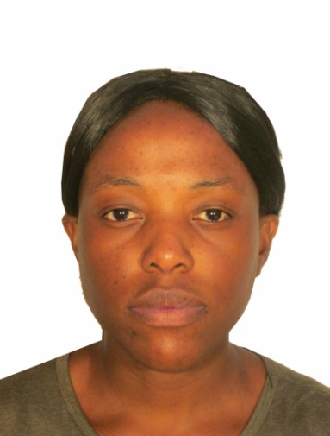
Curriculum Vitae For Rachel Tapererwa
Email address:-tapererwarachel@gmail.com

PERSONAL DETAILS

Born: 27-03-87

Nationality: Zimbabwean
Sex: Female
Languages: Shona/ English
Marital Status: Single
Mobile number: +263 773531056/ +263 772397079
Licence number: 15388JZ (Class 4)

Passport number: CN983550

PERSONAL PROFILE
-An innovative, energetic, loyal, goal driven, team player with good communication skills and willing to learn.
-Highly motivated with a passion for customer relationship management and marketing.
-Experienced in customer services and marketing.
-Effective problem solving and negotiating skills.
-Excellent interpersonal skills.
-Able to meet deadlines of assigned work.

ACADEMIC QUALIFICATIONS

Midlands State University

Masters in Strategic Management and Corporate Governance(February 2019- March 2021)

Chinhoyi University of Technology (August 2007- November 2011)

Bachelor of Technology Honors Degree in Retail Management
Overall Class 2.1

Advanced Level Certificate

Mathematics (D), Accounting (E), Management of Business (C)

Ordinary Level Certificate
-English Language (B)
-History (B)
-Shona (B)
-Mathematics (C)
- Integrated Science (B)
-Food and Nutrition (C)
-Accounts (B)
- Religious Studies (A)
-Computer Packages (Credit)

Computers: Excel
: Word
: Power Point
: Microsoft Outlook

PROFESSIONAL COURSES

CIS PART A

Quantitative Techniques (Pass)
Business Communication (Pass)
Business Law (Pass)
Financial Accounting (Pass)

WORK EXPERIENCE

Kopje Spare Parts Distributors March 2020-August 2021
Branch Manager
Duties
- Manning the shop
- Training staff
- Addressing customer queries
- Preparing weekly and monthly reports
- Monitoring and replenishing stock
- Any other duties

Uniform Centre October 2018-November 2019
Duties
- Benchmarking
- Placing purchase orders
- Shop maintenance
- Ensuring stock availability
- Training staff
- Marketing
- Preparing quotations and setting prices
- Interacting with stakeholders

SPAR ZIMBABWE February 2016- August 2018
Administrator
Duties
  - Maintaining inventory of office supplies
  - Placing purchase orders
  - Monitor processing of branch transactions
  - Developing and maintaining good relationships with clients and staff
  - Coordinate with Accounts payable department and monitor all payments to the branch

Sales and Marketing Officer Jan 2014-APRIL 2015
BLUETEK GENERATORS
- Manning the showroom
- Marketing of products
- Preparing tender documents
- Sales and stock Planning
- Coordinating and participating in promotional activities

Sales and Marketing Assistant Jan –December 2013
DIE & PRESSURE CASTINGS
- Sales analysis and sales reports
- Sales and stock planning
- Handling customer related issues
- Coordinating and participating in promotional activities
- Developing and updating clients database
- Receipting, invoicing and revenue collection

REFEREES:

Liberty Maziti
Kopje Spare Parts Distributors
+263772994139

Mr Gift Nyamumba

SPAR Ballantyne
Harare
+263(242)886632/3

Mr. T.Ndongwe
Die & Pressure Castings (Pvt) Ltd
Msasa
Harare
+263772 888904

